***Documentation***

**Title: FLOSSK Bootcamp**

**Project description:**

The project combined two initiatives, the "FLOSSK Bootcamp" and the "TECH JOB ACCELERATOR," both aimed at reducing youth unemployment in Kosovo by providing essential IT training and internship opportunities. These programs focused on equipping young people with skills in programming, web development, database management, and additional IT disciplines such as hardware and electronics, the Linux operating system, Python, QA, MERN stack, and woodwork and carpentry.

Participants received comprehensive hands-on training and access to internship placements, enhancing their employability and fostering career development. Through user groups, the project promoted capacity building, experience sharing, knowledge expansion, and partnership creation.

**Activities:**Key activities:

Delivered **9-week intensive training**, held 4 times a week, with sessions including 2 hours of lectures and 2 hours of exercises.

**Training topics included**: MERN Fullstack (MongoDB, Express, React, Node), programming, web development, hardware, electronics, QA, and carpentry.

Conducted workshops and seminars to enhance practical IT skills and prepare students for the workforce.

Facilitated **internship placements**:

* 5 placements with local companies for 3 months, with future employment potential.
* Coordinated placements with 6 private IT companies, offering students real-world experience and networking opportunities.

**Photos:**

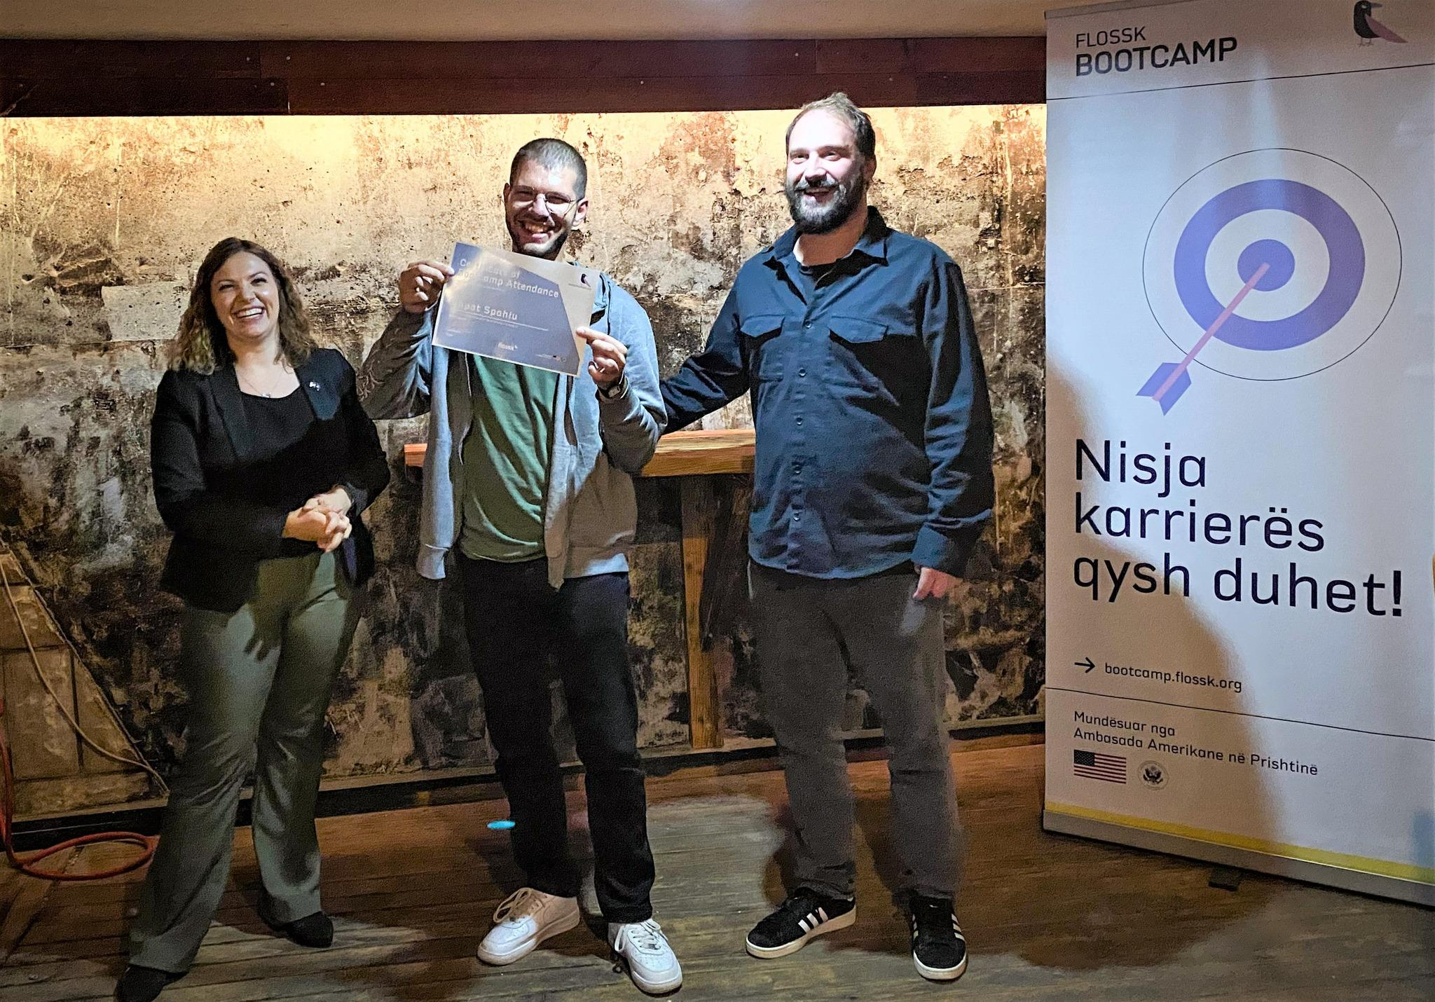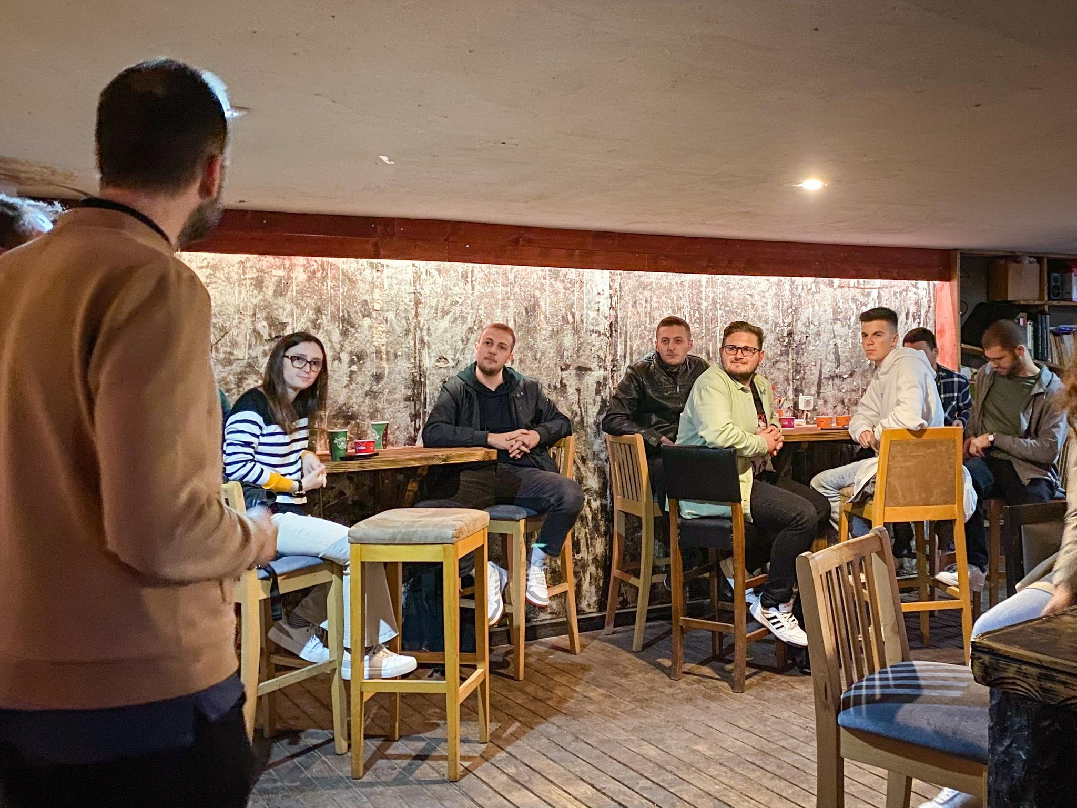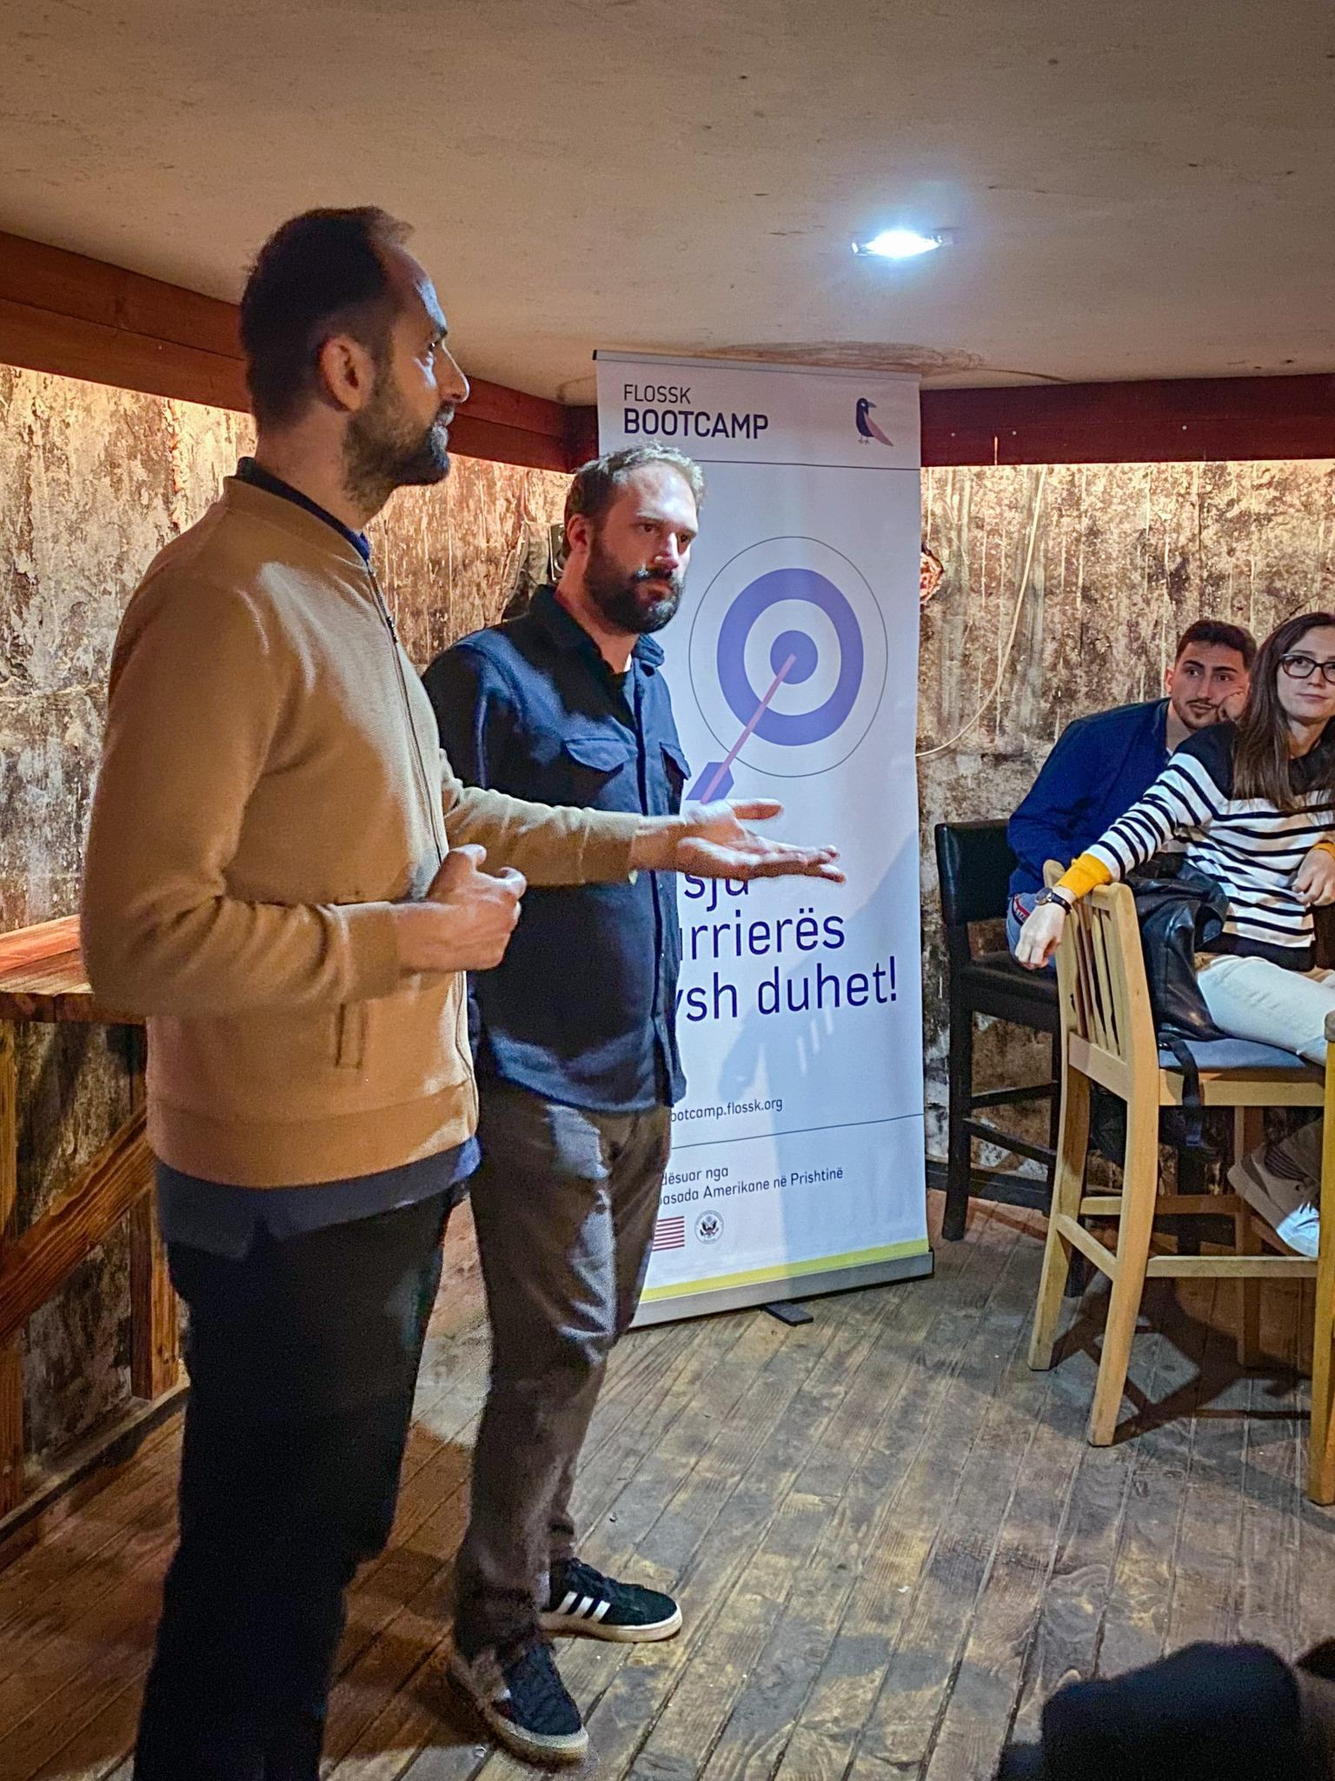

**Beneficiaries:**

* **66 participants**: 54 students completed the TECH JOB ACCELERATOR, while 12 university students completed the FLOSSK Bootcamp, gaining entry-level programming skills and hands-on experience to enhance employability.
* **Partner companies**: Local businesses benefited from a pool of job-ready candidates, with six private IT companies partnering in the project.

**Partners:**

* N/A

**Budget:  
€84,360.05**

**Project duration**:

FLOSSK Bootcamp: **July - December 2023**

TECH JOB ACCELERATOR: **January 1, 2022 - July 31, 2023**

*This document is FLOSSK intellectual property - Do not share without authorization from FLOSSK.*